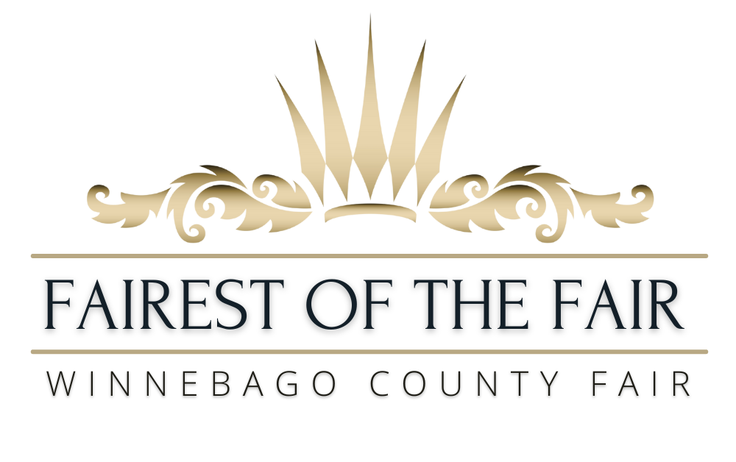

Pre-Fair Judging July 27-28 • July 29-August 2, 2026 • “Country Roads Take Me Home”
CONTEST ENTRY FORM • DEADLINE MARCH 31 • CONTEST APRIL 18
Entry materials can be submitted by mail or email to:
Fairest of the Fair (FOTF) • ℅ Jill Butt • 106 County Road M • Pickett, WI 54964
jvzentner@gmail.com

- Contestant Information Sheet: Please see next page.

- Photo: Please submit 1-2 photos of yourself
- Current photo where we can clearly see your face (head shots are best!)
- You are also welcome to submit a second photo of yourself participating in a County Fair event.

- Profile: Please tell us about yourself by writing a 1-2 paragraph profile. This profile will be shared with judges, used to introduce you at events and in our social media promotions. A good profile is short and to the point, grabs people’s attention quickly and highlights the most important information about you!
Suggestions on what to include:
- Name & City you live in • Personal interests (i.e. hobbies, goals & ambitions, special talents, etc.)
- Professional information (i.e. school, work, experiences relevant to FOTF, awards/honors, etc.)
- What makes you an amazing ambassador for the Fair?

- FAQ (Frequently Asked Questions): Page 3 of the Entry Form includes questions our Fair representatives get asked ALL THE TIME during interviews or at events. Your answers will help our judges get to know you…AND will give you some practice answering these types of questions before you have to do it in person! Your answers should be short (only 2-3 sentences), to the point and engage the person reading them!
- Determine what the main point of the question is, and focus on one clear and direct answer.
- These questions demonstrate your ability to give an “Elevator Speech”. An Elevator Speech is a very short “speech” you can give in the amount of time it takes to ride in an elevator with someone to answer a question or get them excited to learn more. This same concept applies to Social Media, where you only have 1-2 sentences to grab someone’s attention before they scroll past your post.

- Fair Radio Advertisement: Please write a 60 second script for a radio ad for the County Fair. Your ad should inspire others to attend the Fair. Check out the Fair Website, Facebook or talk to a Fair Board Director for Fair info to use in your advertisement. TIPS for your Radio Ad:
- Do your research - listen to other event ads on the radio station right now (online, in your car, etc.)
Cumulus Stations (99.5 PKR, 96.9 The Fox & 103.9 WVBO) are Fair Sponsors and good to listen to for ideas.
- Be creative & incorporate your personal interests. Genuine enthusiasm will grab the audience’s attention.
- Time your written script while reading it out loud. 60 seconds are a lot shorter than you think!

- Optional Information: Contestants may submit 1 additional item of your choice with your entry materials (i.e. a resume, portfolio, marketing/event plan, community service idea, etc). This is NOT a scored component.

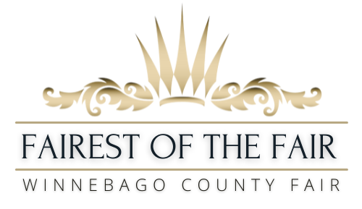
Contestant Information Sheet:

Name:___________________________________________________________________

Age:_________________________________ Date of Birth:_______/_______/_________
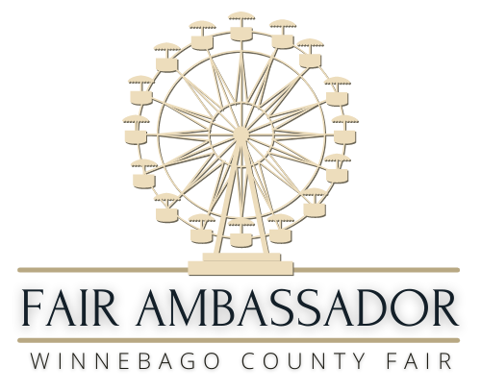
Email:______________________________________Phone: _______________________

Mailing Address: __________________________________________________________
City: ____________________________________ State: ________ Zip: ______________
Dates for using this address: Start: _______________ End:________________

Permanent Address (if different than above):__________________________________________________________

City:___________________________________________________________ State:________ Zip:_______________
Have you ever been convicted of a felony? Y / N

Secondary Contact Info (Parent, guardian, spouse, partner, etc that can be sent event notifications and contacted in an emergency)
Name:_______________________________________________Relationship to You: _________________________

Phone:_____________________________________ Email:______________________________________________

Name:_______________________________________________Relationship to You: _________________________

Phone:_____________________________________ Email:______________________________________________

1. Have you reviewed: Program Overview Y / N Fair Promotion Schedule (Tentative) Y / N
Please contact the Program Coordinator directly with any questions or concerns

2. Are you planning to be a YOUTH EXHIBITOR at this year’s Fair? Y / N

3. To the best of your knowledge, will you be able to fulfill the duties of this position? Y / N

4. If chosen for this position, do you prefer to be referred to as “Fairest of the Fair” OR “Fair Ambassador”
(Please circle your preferred title)

5. Do you require any accommodations to participate in this contest or to complete the position duties?: Y / N
If yes, please describe:

FOTF CONTEST ENTRY FORM • DEADLINE MARCH 31 • CONTEST APRIL 18
Entry materials can be submitted by mail or email to:
Fairest of the Fair • ℅ Jill Butt • jvzentnter@gmail.com
106 County Road M • Pickett, WI 54964
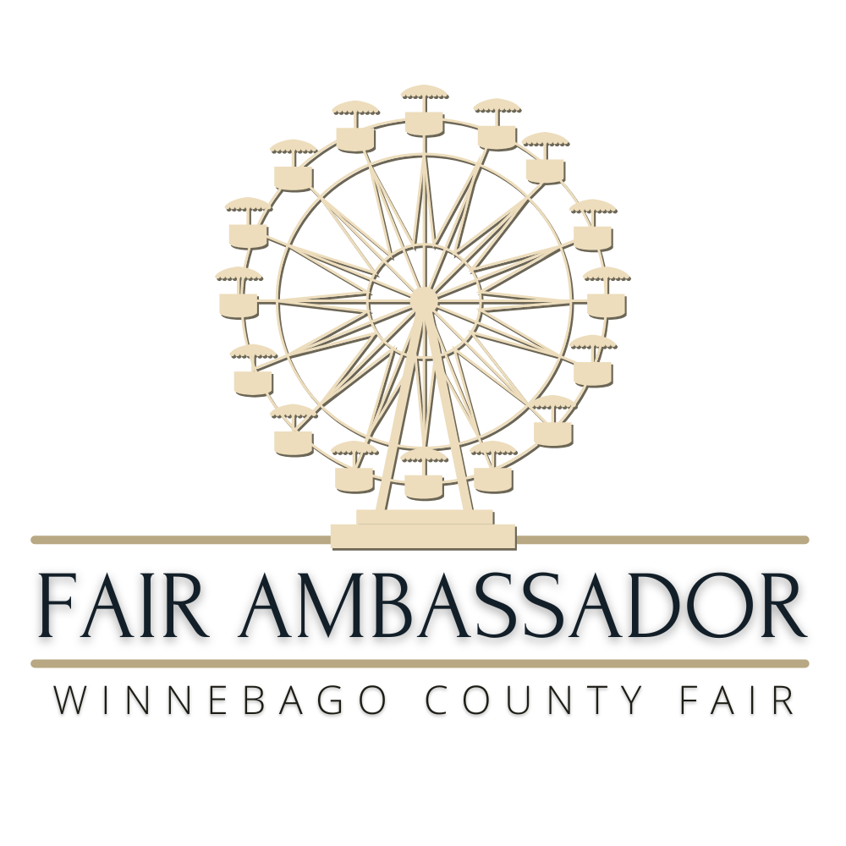
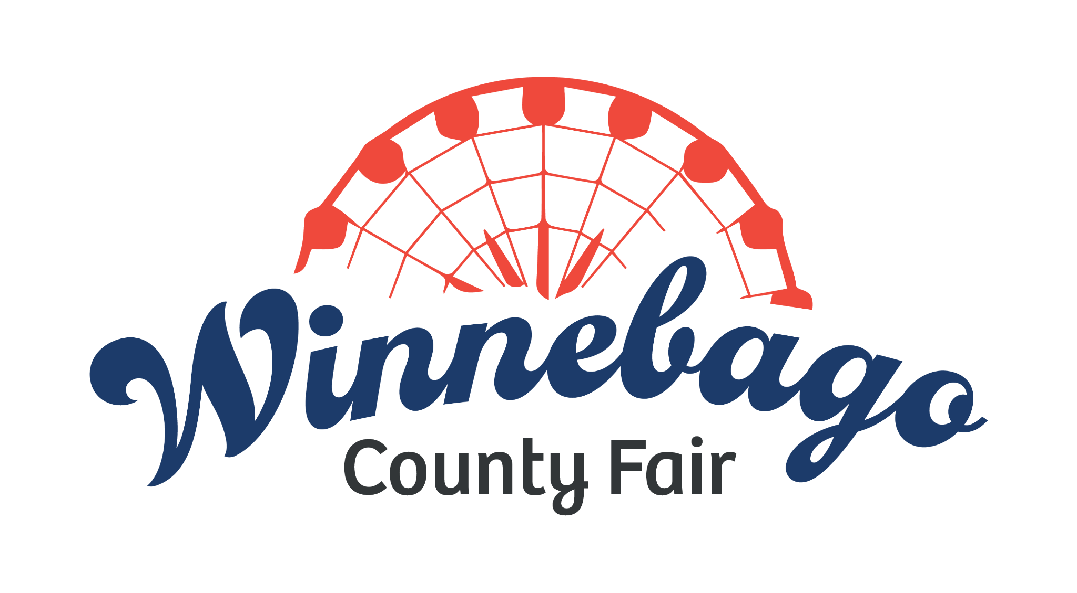

FAQ (Frequently Asked Questions):
This is your chance to give us your best “elevator speech” in response to these questions. Please keep answers to 2-3 sentences in length (see additional tips on page 1 of the Entry Form).

- What is ONE of your skills/talents that you would use in the role of Fairest of the Fair/Fair Ambassador? How will this skill/talent enhance our Fair promotions?

- What is your favorite part of the Winnebago County Fair and Why?

- How would you describe a County Fair to someone who has never attended a Fair before?

- If you had to eat ONE Fair Food for the rest of your life, what would it be and why?

- What is your definition of a role model?

- If you could make ONE suggestion to improve the Winnebago County Fair, what would it be and why?

- During a live interview the broadcaster asks questions about events at your fair that you’re not familiar with, how would you respond?

